Visual Statistics User Guide

Table of Contents

1. Introduction 1

2. Graph User Interface 1

2.1. Main Window 1

2.1.1. Add statistics files to file list view 2

2.1.2. Filter out statistics names 2

2.2. Plot Window 3

2.2.1. The tool bar 3

2.2.2. The main area 4

# Introduction

This program is used to visualize statistics files data. It is similar to csv_to_graph.py except this program is based on GUI. And besides of this difference there are some advantages compare to csv_to_graph.py, which makes the statistics analysis more straightforward.

* Parsing files much faster
* Interactively switch between normal mode and delta mode
* It is possible to mark abnormal time
* Interactively scale up and down image in plot window
* Supporting save not only the parsed image but also the parsed data

Currently support Windows and Linux (Ubuntu).

# Graph User Interface

## Main Window

The main window is used to add statistics files, which you want to analyze, to **file list view** (on the left) and filter out statistics names, etc.

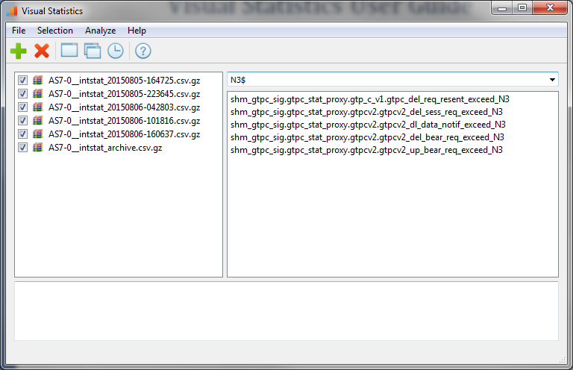

### Add statistics files to file list view

Once you want to start your analysis, the first thing you need to do is add one or more statistics files to **file list view** (or open a plot file, which we’ll discuss later). You can use the tool button **[Add]** to select the files from the **open file dialog** or you can drag files directly to the main window.

After adding the files, the program will parse the files’ header automatically. The header contains the statistics names in the statistics file. Once the program completes parsing the header, all the statistics names will be shown to the **statistics name list view** (on the right).

Plot file (have .plot extension name) is a private file format which contains the parsed statistics values. With this file you can open it later to show the parsed value in plot window, this is much faster than open the original statistics csv file because there is no file parsing.

### Filter out statistics names

After adding the statistics files you can select one or more statistics names in the **statistics name list view** and press **[Draw Plot]**/**[Draw Plot In Multiple Windows]** tool button to draw the statistics values. If you don’t select any statistics name, all the shown statistics names will be parsed and shown. Please note that the count of statistics name to be parsed should not exceeded 6.

Because there are a lot of statistics names and probably you cannot easily find out the statistics names which you want, so you may want to use regular expression to filter out the needless statistics names from the view.

The difference between **[Draw Plot]** and **[Draw Plot In Multiple Windows]** is that the former will draw all the parsed statistics values in one window while the latter will draw each parsed statistics value in a separate window.

## Plot Window

The plot window is the place where the parsed statistics values be drawn. It contains a tool bar and a main area that to show the drawn image.

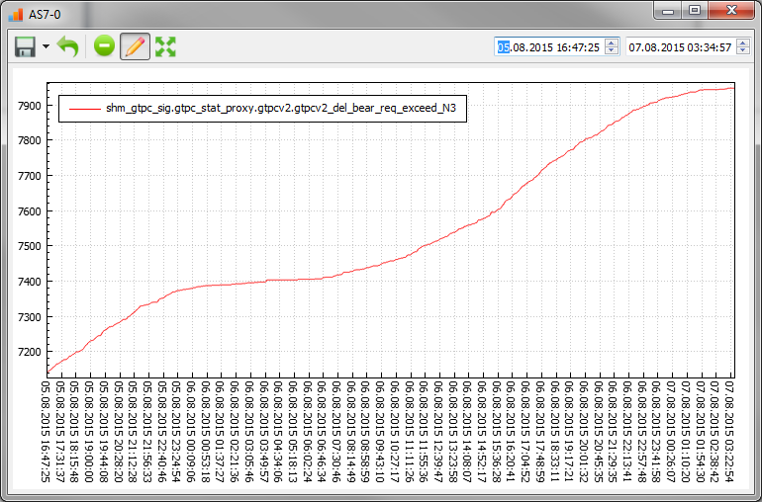

### The tool bar

The tool bar contains tool buttons and each button has its own functionality.

* **Save As Image/Save To File**

Press the first button trigger the **Save As Image** functionality which will save the drawn image to a .png file. Alternatively, on the right side of this button there is an arrow and press this arrow you can choose to save the parsed data to a .plot file which we have discussed previously.

* **Restore Scale**

Because this program supports scale interactively, you can press this button to restore the scale to 1:1 at anytime.

* **Show Delta**

Press this button will switch between normal mode and delta mode. In normal mode the parsed value will be drawn by its original value. In delta mode the parsed value is drawn by its value minus the parsed value before it. For example the original parsed values are [10, 12, 15, 20, 45], in delta mode the parsed value will translate to [0, 2, 3, 5, 25] (the first value in delta mode is always 0).

* **Mark abnormal time**

In normal circumstances the time difference between each sample is nearly constant. We can use this button to mark the abnormal sample, for example the following picture has an abnormal sample, the time before this sample is 12:41:10 the time difference is nearly four hours which is obviously abnormal.

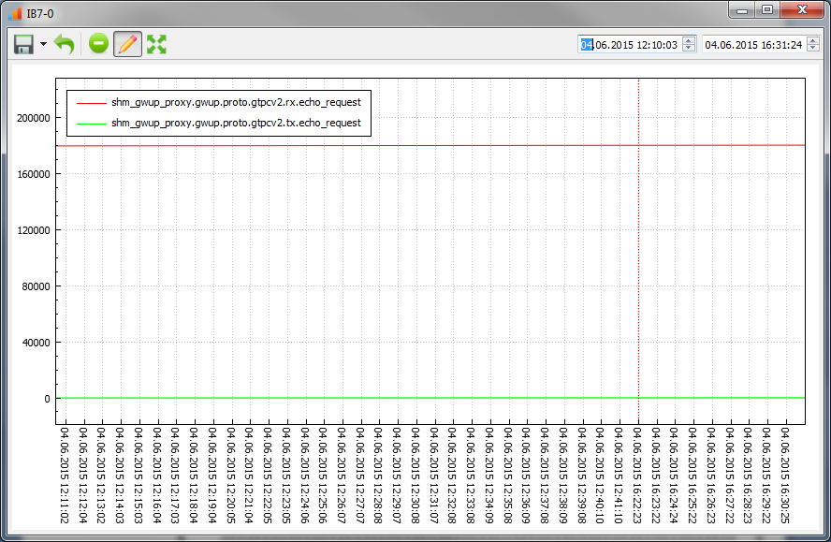

* **Full Screen**

Show plot window full screen mode.

### The main area

The main area is the place where the parsed data drawn and you operate on. The following chapter will discuss some of the supported operation.

* Scale up and down

When you want to see the more accurate value or time you can scale up the image using mouse wheel. When scaling, press **Ctrl Key** to only scale the X axis or press **Shift Key** to only scale Y axis.

* Dragging

Press the left mouse button and move it you can drag the drawn image. This is useful when you scale up the image that only part of it can be shown in plot window. On the right side of tool bar the edit boxes show the time duration shown in plot window. You can also edit it to specify the time duration to shown.